EXPERIMENT 4: ENTROPY, CROSS-ENTROPY AND KL DIVERGENCE

1. Aim
To calculate the entropy of an observed weather distribution and evaluate two competing forecasting models using cross-entropy and KL divergence. To verify the relationship between entropy, cross-entropy, and KL divergence, demonstrate the asymmetry of KL divergence, and visualize binary cross-entropy loss using NumPy, SciPy, and Matplotlib.

2. Formulas
1. Entropy: H(P) = -Σ P(x) log₂ P(x)
2. Cross-Entropy: H(P, Q) = -Σ P(x) log₂ Q(x)
3. KL Divergence: D_KL(P || Q) = Σ P(x) log₂ [P(x) / Q(x)]
4. Cross-Entropy Relationship: H(P, Q) = H(P) + D_KL(P || Q)
5. KL Divergence in Reverse: D_KL(Q || P) = Σ Q(x) log₂ [Q(x) / P(x)]
6. Binary Cross-Entropy Loss: L = -[y log(p) + (1 - y) log(1 - p)]
Where:
P = True probability distribution
Q = Predicted probability distribution
y = Actual binary label (0 or 1)
p = Predicted probability
3. Overall Flow Diagram
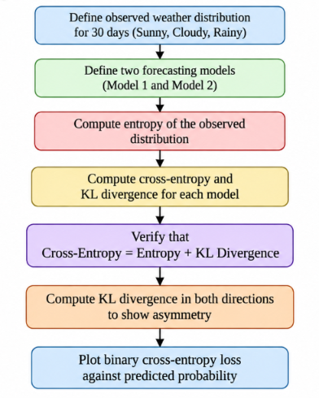

4. Code :
import numpy as np
import matplotlib.pyplot as plt
from scipy.stats import entropy

weather = np.array([
12, 10, 8
], dtype=float)

P = weather / weather.sum()

Q1 = np.array([0.50, 0.30, 0.20])
Q2 = np.array([0.30, 0.40, 0.30])

print("True Distribution:", P)

H_P = entropy(P, base=2)
print("\nEntropy:", round(H_P, 4), "bits")

H_P_Q1 = -np.sum(P * np.log2(Q1))
H_P_Q2 = -np.sum(P * np.log2(Q2))

KL_P_Q1 = entropy(P, Q1, base=2)
KL_P_Q2 = entropy(P, Q2, base=2)

print("\nModel 1 Cross-Entropy:", round(H_P_Q1, 4))
print("Model 1 KL Divergence:", round(KL_P_Q1, 4))

print("\nModel 2 Cross-Entropy:", round(H_P_Q2, 4))
print("Model 2 KL Divergence:", round(KL_P_Q2, 4))
print("\nVerification for Model 1:",
np.isclose(H_P_Q1, H_P + KL_P_Q1))
print("Verification for Model 2:",
np.isclose(H_P_Q2, H_P + KL_P_Q2))

KL_Q1_P = entropy(Q1, P, base=2)
KL_P_Q1 = entropy(P, Q1, base=2)
print("\nKL(P || Q1):", round(KL_P_Q1, 4))
print("KL(Q1 || P):", round(KL_Q1_P, 4))
p = np.linspace(0.001, 0.999, 500)

loss_y1 = -np.log(p)
loss_y0 = -np.log(1 - p)

plt.figure(figsize=(8, 5))
plt.plot(p, loss_y1, label="Actual label = 1")
plt.plot(p, loss_y0, label="Actual label = 0")

plt.xlabel("Predicted Probability")
plt.ylabel("Binary Cross-Entropy Loss")
plt.title("Binary Cross-Entropy Loss vs Predicted Probability")
plt.legend()
plt.grid(True)
plt.tight_layout()
plt.show()

labels = ["Sunny", "Cloudy", "Rainy"]
x = np.arange(3)
width = 0.25

plt.figure(figsize=(8, 5))
plt.bar(x - width, P, width, label="Observed")
plt.bar(x, Q1, width, label="Model 1")
plt.bar(x + width, Q2, width, label="Model 2")

plt.xticks(x, labels)
plt.ylabel("Probability")
plt.title("Observed and Predicted Weather Distributions")
plt.legend()
plt.tight_layout()
plt.show()
5. Output
True Distribution: [0.4 0.33333333 0.26666667]

Entropy: 1.5656 bits

Model 1 Cross-Entropy: 1.5982

Model 1 KL Divergence: 0.0326

Model 2 Cross-Entropy: 1.5986

Model 2 KL Divergence: 0.03

Verification for Model 1: True

Verification for Model 2: True

KL(P || Q1): 0.0326

KL(Q1 || P): 0.0324

Graph
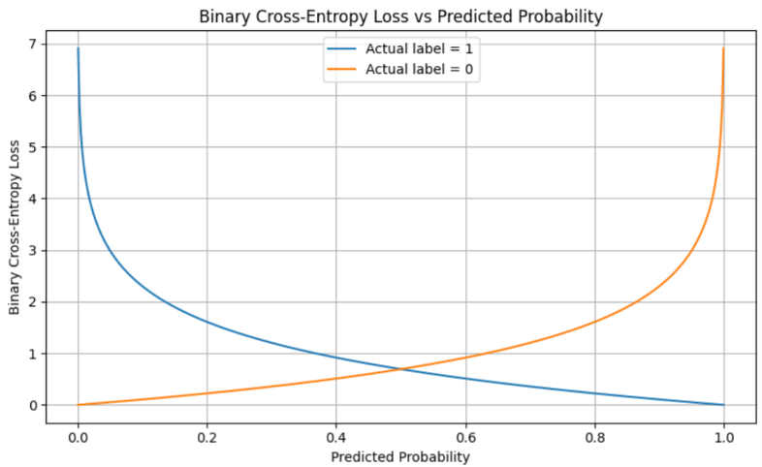
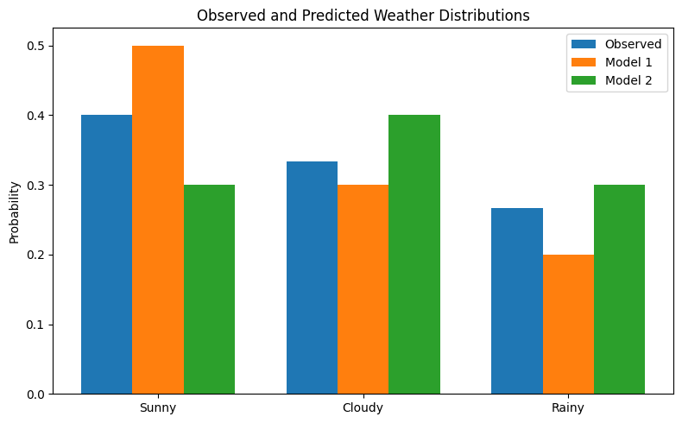

6. Result
Entropy, cross-entropy, and KL divergence were calculated successfully for the observed weather distribution and two forecasting models. The relationship between cross-entropy, entropy, and KL divergence was verified. KL divergence was shown to be asymmetric, and binary cross-entropy loss was visualized using Matplotlib.

